|  |  |  |
| --- | --- | --- |
|  |  | Photo |
|  | YILDIZ TECHNICAL UNIVERSITYFACULTY OF APPLIED SCIENCESDEPARTMENT OF AVIATION ELECTRONICSINTERSHIP REPORT COVER PAGE |
|  |  |

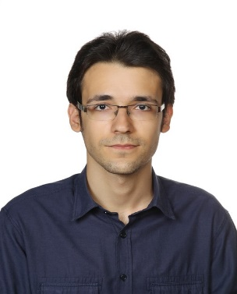

|  |  |  |  |
| --- | --- | --- | --- |
| STUDENT AND INTERNSHIP INFORMATION | | | |
| STUDENT | | **INTERNSHIP** | |
| Name & Surname | Uygar Tolga Kara | Type of Internship | Vocational I |
| Student ID Number | 190B1016 | Number of Working Days | 30 |
| Year & Semester | 3 / 6 | Starting Date | 27/06/2022 |
| Phone Number | 0541 596 1996 | Signature |  |
| E-Mail | uygartolgakara@gmail.com |

|  |  |  |  |  |
| --- | --- | --- | --- | --- |
| **FIELD OF WORK** | | | | |
|  | **FIELD** | **STARTING DATE** | **END DATE** | **WEEK** |
| **1** | Automation (Python) - Calibration | 27/06/2022 | 11/08/2022 | 7 |
| **2** |  |  |  |  |
| **3** |  |  |  |  |
| **4** |  |  |  |  |
| **5** |  |  |  |  |

|  |  |  |
| --- | --- | --- |
| APPROVAL OF THE INTERSHIP SUPERVISOR | | |
| **NOTES** | Thank you for your time, consideration and interest in our internship program.  The interns cannot work on weekends, holidays.  Internship can be approved by any ones who have titles listed in the department internship instruction. | |
| **ORGANIZATION** | Name and Title | Bosch San. ve Tic. A.Ş. |
| Field of Work | Manufacturing, R&D, Information Technology, Design, Mobility Solutions |
| Phone number | 444 32 11 |
| Website | https://www.bosch.com.tr/iletisim/ |
| Address & Stamp | Küçükyalı Ofispark A Blok 34854 Maltepe, İstanbul |
| **SUPERVISOR** | Name & Surname | Selim Çökren |
| Title | Application and Calibration Engineer |
| Duty | Safety Calibration |
| Phone | +90(216)4320-483 |
| E-mail | Selim.Cokren@tr.bosch.com |
| Date | 11/08/2022 |
| Signature & Stamp |  |